DATE: 19.06.2025
Python Coding Challenge

Topic: List, Tuple, Dictionary, Set | Total Questions: 10 | Time: 60 minutes
Section A: List (3 Questions):
Section B: Tuple (2 Questions):
Section C: Dictionary (3 Questions):
Section D: Set (2 Questions):
Q1. Write a Python program to remove all duplicates from a list without using the set() function.
Input Example: [1, 2, 2, 3, 4, 4, 5]
Output: [1, 2, 3, 4, 5]

lst = [1, 2, 2, 3, 4, 4, 5]
unique_list = []
for item in lst:
if item not in unique_list:
unique_list.append(item)
print(unique_list)
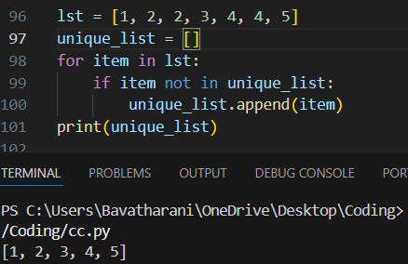

Q2. Given a list of integers, write a program to find the second highest unique number.
Input Example: [12, 5, 9, 21, 21, 3]
Output: 12

lst = [12, 5, 9, 21, 21, 3]
unique_nums = list(set(lst))
unique_nums.sort(reverse=True)
print(unique_nums[1]) 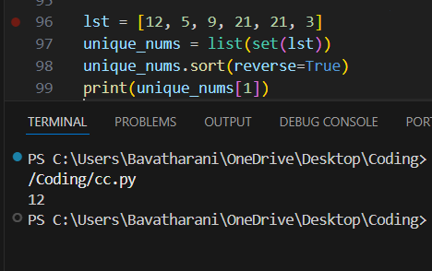

Q3. Rotate a list to the right by k positions.
Input: List = [1, 2, 3, 4, 5], k = 2
Output: [4, 5, 1, 2, 3]

lst = [1, 2, 3, 4, 5]
k = 2
k = k % len(lst)
rotated = lst[-k:] + lst[:-k]
print(rotated)

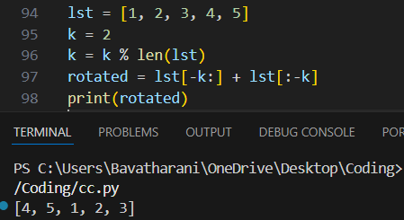

Q4. Write a Python program to multiply the elements of each tuple in a list of tuples and return a new list.
Input: [(2, 4), (3, 5), (4, 6)]
Output: [8, 15, 24]

tuples = [(2, 4), (3, 5), (4, 6)]
result = []
for a, b in tuples:
result.append(a * b)
print(result)
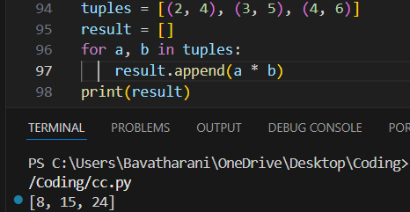

Q5. Given a tuple of integers, write a program to count how many times each element occurs.
Input: (1, 2, 2, 3, 1, 4, 2)
Output: {1: 2, 2: 3, 3: 1, 4: 1}

tpl = (1, 2, 2, 3, 1, 4, 2)
freq = {}
for item in tpl:
if item in freq:
freq[item] += 1
else:
freq[item] = 1
print(freq)
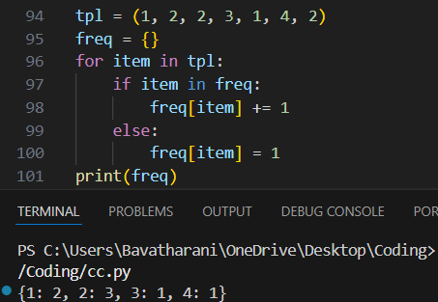

Q6. Write a Python program to count the frequency of each character in a string using a dictionary.
Input: 'banana'
Output: {'b': 1, 'a': 3, 'n': 2}

s = 'banana'
freq = {}
for ch in s:
if ch in freq:
freq[ch] += 1
else:
freq[ch] = 1
print(freq)
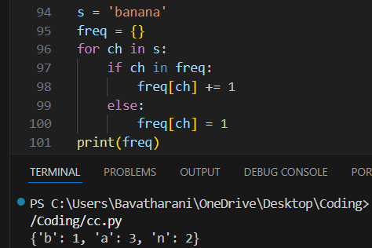

Q7. Merge two dictionaries such that common keys have their values summed.
Input: {'apple': 10, 'banana': 5}, {'banana': 3, 'orange': 7}
Output: {'apple': 10, 'banana': 8, 'orange': 7}

d1 = {'apple': 10, 'banana': 5}
d2 = {'banana': 3, 'orange': 7}
merged = d1.copy()
for key in d2:
if key in merged:
merged[key] += d2[key]
else:
merged[key] = d2[key]
print(merged)
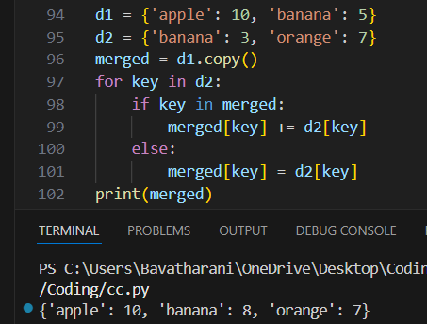

Q8. Given a dictionary of student names and their marks, print the name(s) of the student(s) with the highest marks.
Input: {'Alice': 85, 'Bob': 92, 'Carol': 92}
Output: ['Bob', 'Carol']

students = {'Alice': 85, 'Bob': 92, 'Carol': 92}
max_mark = max(students.values())
top_students = []
for name in students:
if students[name] == max_mark:
top_students.append(name)
print(top_students)
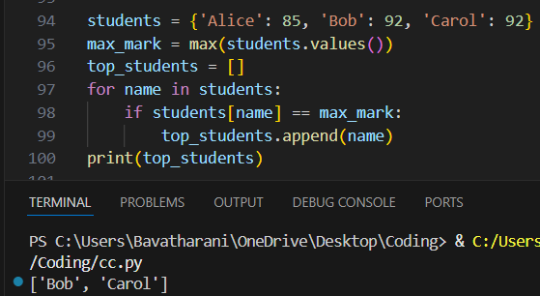

Q9. Write a Python program to find all common elements among three lists using set operations.
Input: [1, 2, 3], [2, 3, 4], [3, 2, 5]
Output: {2, 3}

l1 = [1, 2, 3]
l2 = [2, 3, 4]
l3 = [3, 2, 5]
common = set(l1) & set(l2) & set(l3)
print(common)
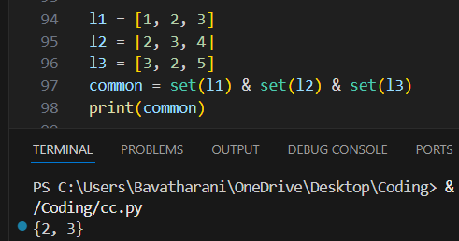

Q10. From a sentence entered by the user, extract and display all unique words using a set.
Input: 'this is a test this is fun'
Output: {'this', 'is', 'a', 'test', 'fun'}

sentence = 'this is a test this is fun'
words = sentence.split()
unique_words = set(words)
print(unique_words)
